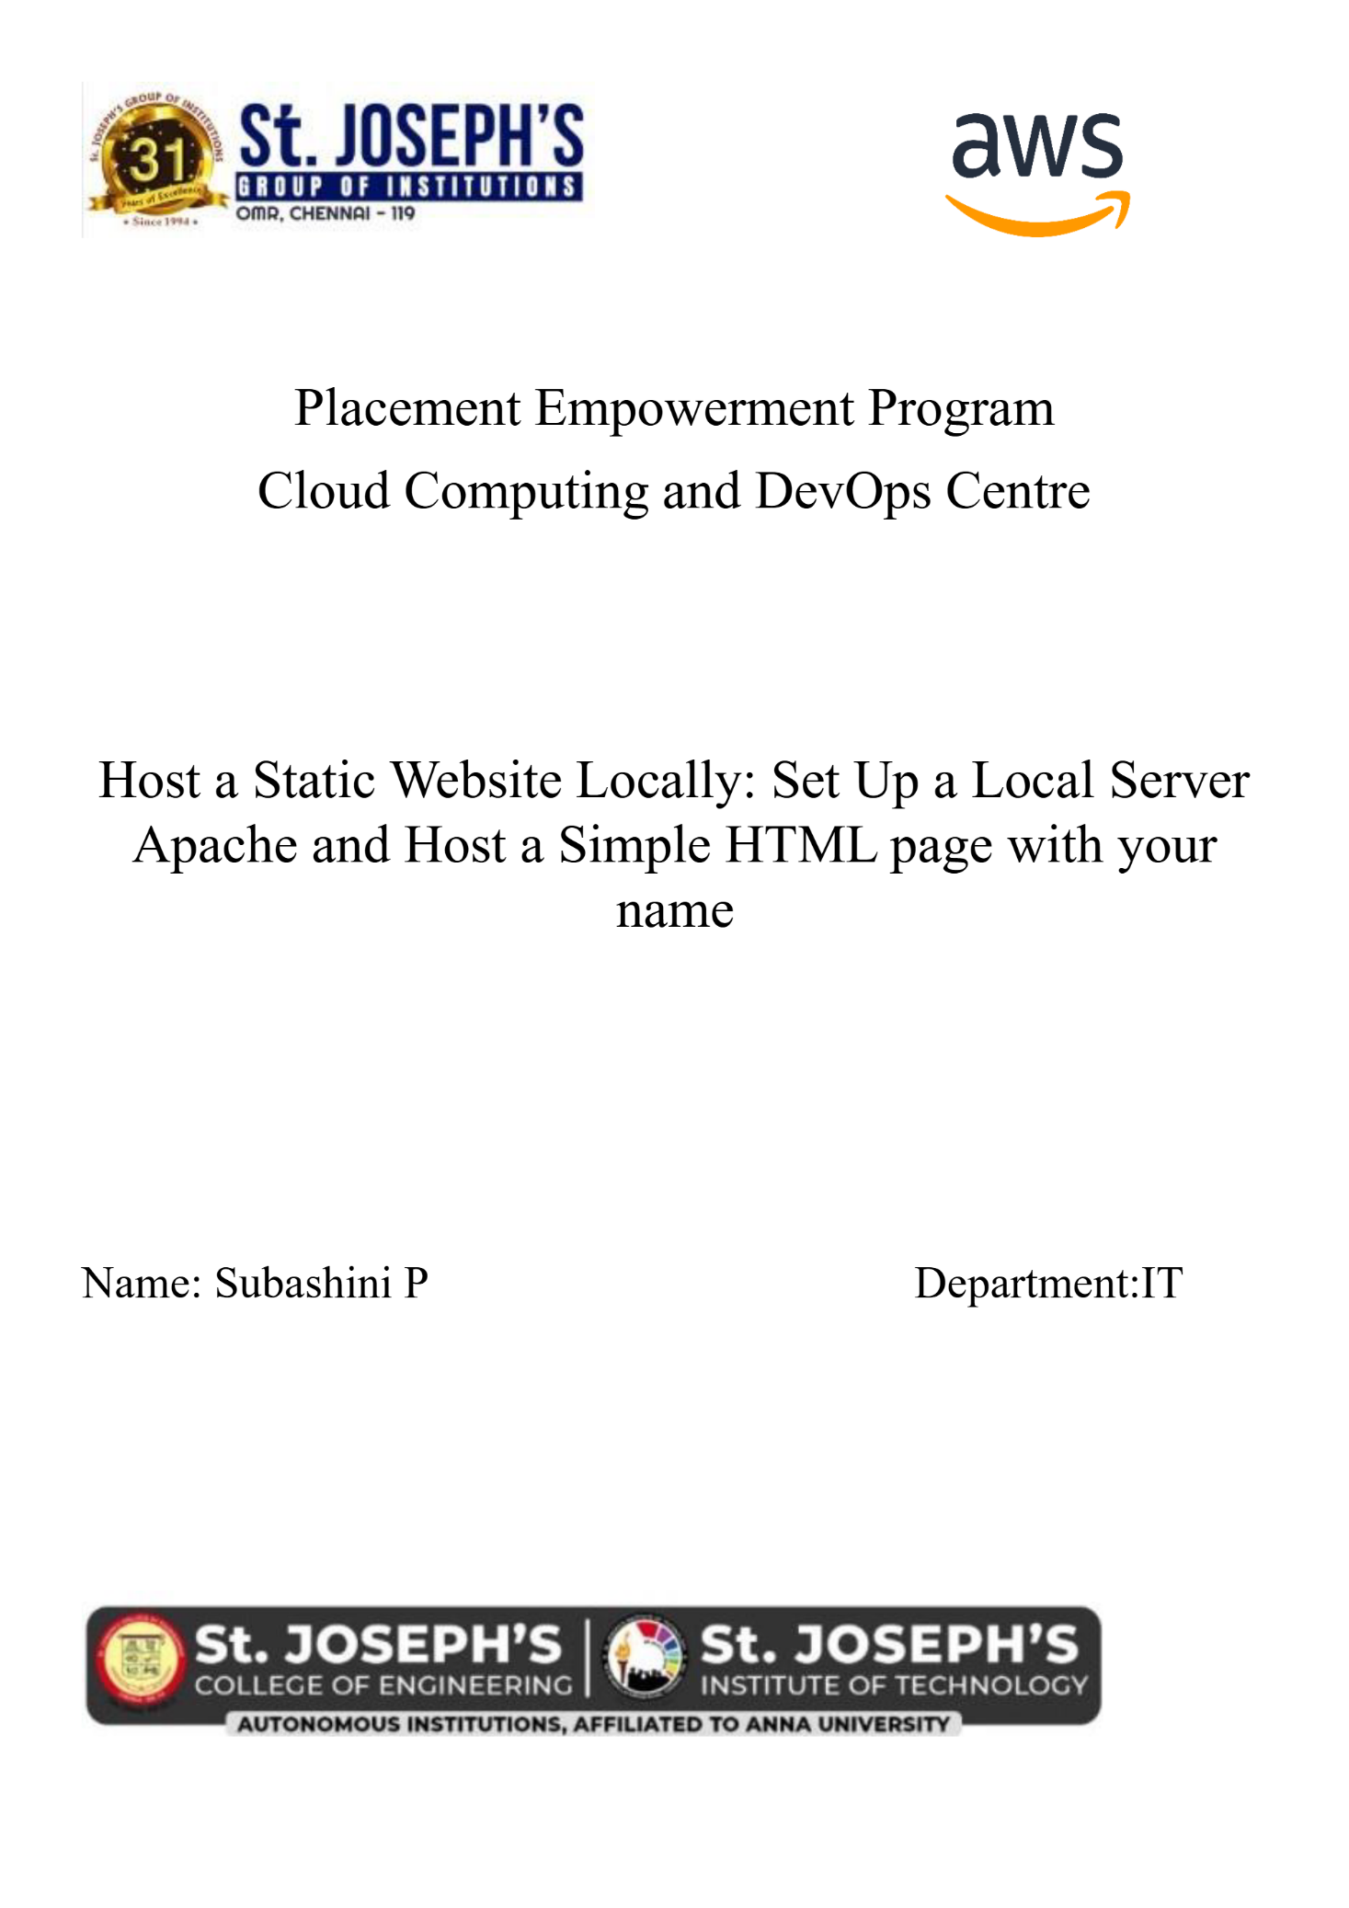

**DHAMINI B**

**NAME :**



**Introduction: Hosting a Static Website Locally**

To get started with web development, it's important to be able to see your website running locally on your own computer before you publish it online. Hosting a static website locally means you can view your site without needing an internet connection.

**Static websites** are basic websites that only contain HTML, CSS, and JavaScript files. These files don't change dynamically and can be easily served by a local web server like **Apache**.

we'll use Apache (a popular web server) to host a simple webpage with your name on it.

**What Needed:**

1. **Apache Web Server**: This will serve your website files locally.
2. **HTML File**: A simple webpage to display your name.

***Step-by-step Overview:***

***Step 1:***

Search for "Apache Lounge" on Google and click the first link.

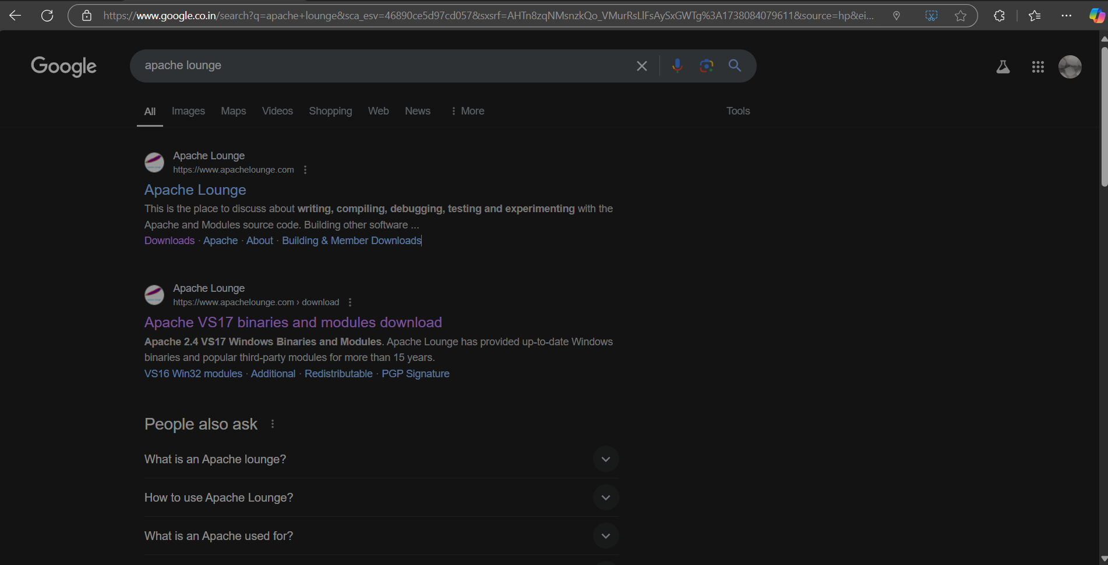

***Step 2 :***

Click on the "Downloads" option located on the left-hand side of the Apache Lounge website. 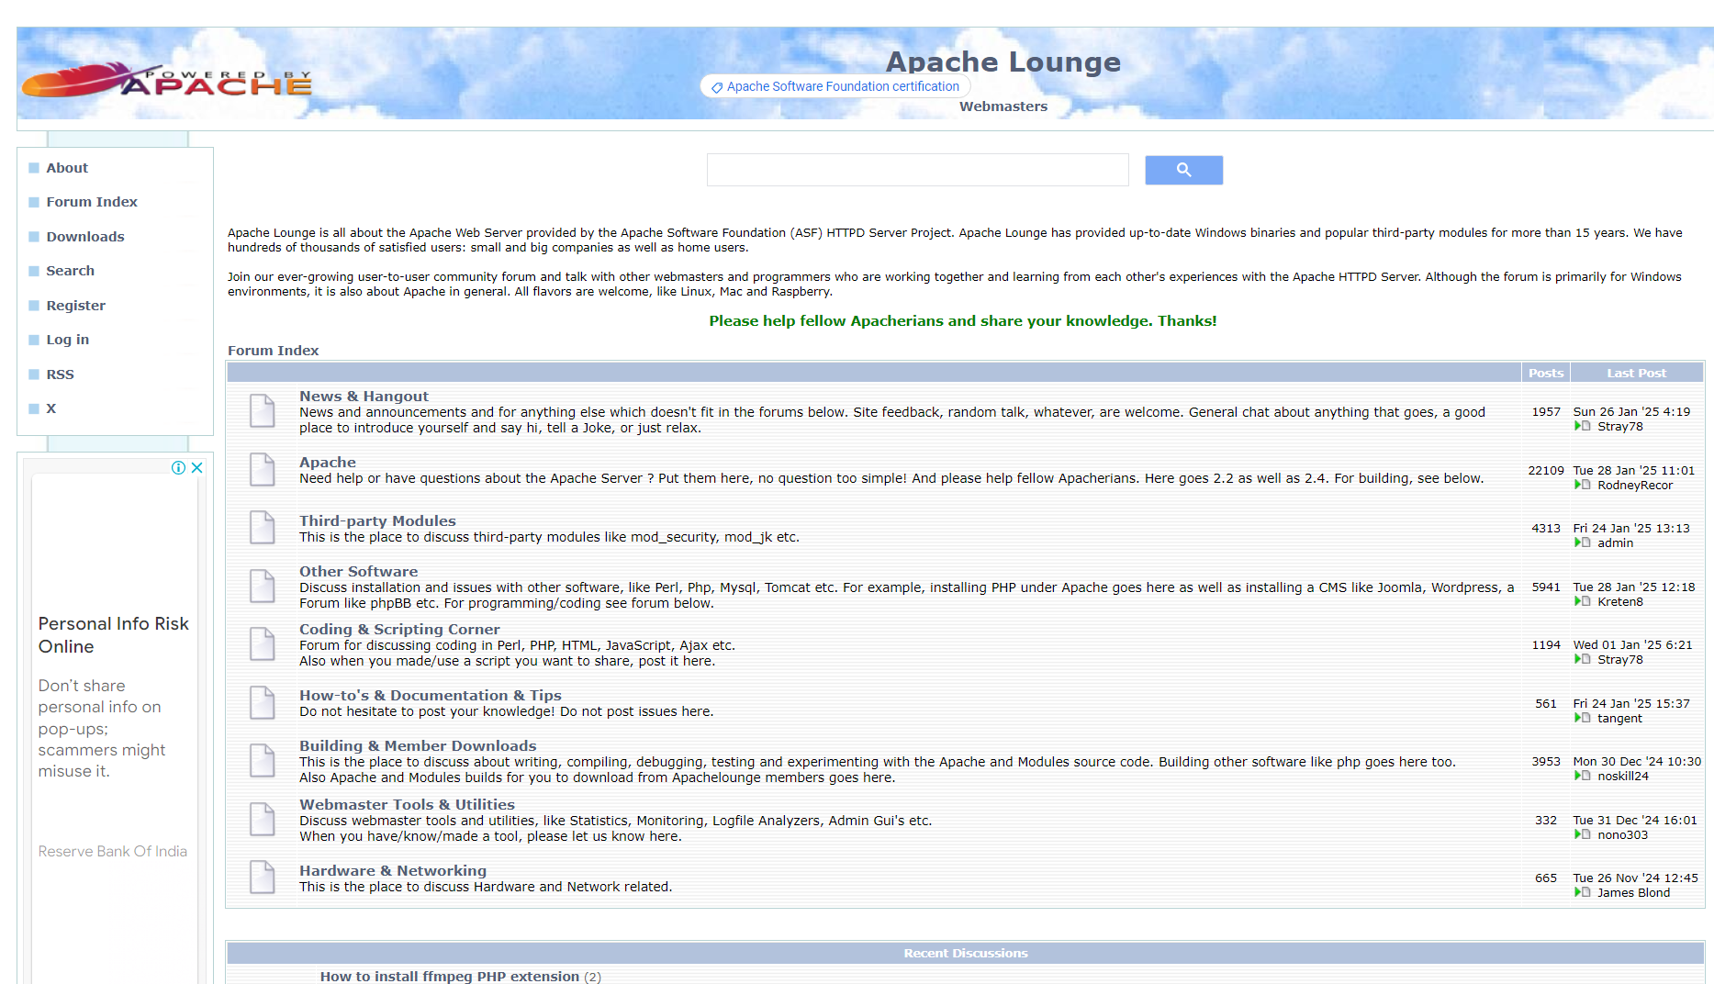Apache Lounge website. 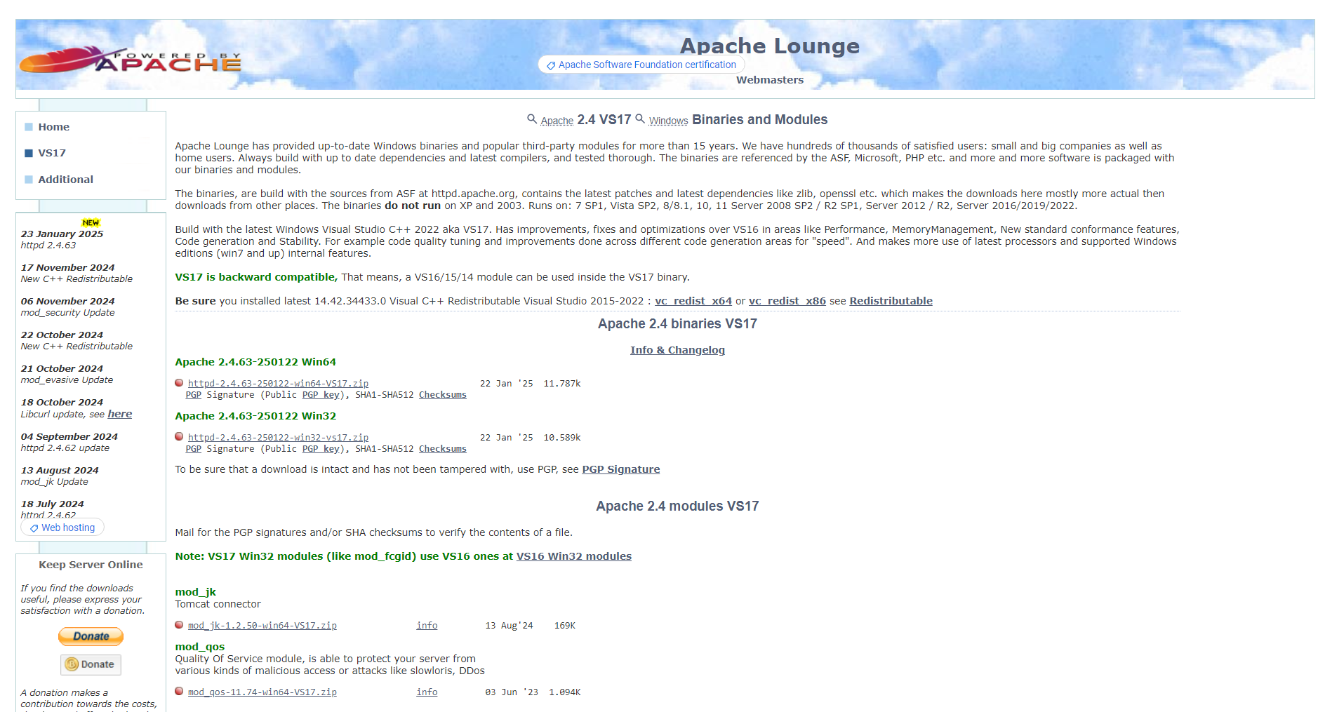

***Step 3 :***

Click on the link "Apache 2.4.63-250122 Win64" (Windows version), download the file, and extract all its contents.

***Step 4 :***

* Open Command Prompt as Administrator.
* Type windows + R, then type cmd, right-click and use the command cd C:\\to\apache\bin to set the path to the Apache bin folder.

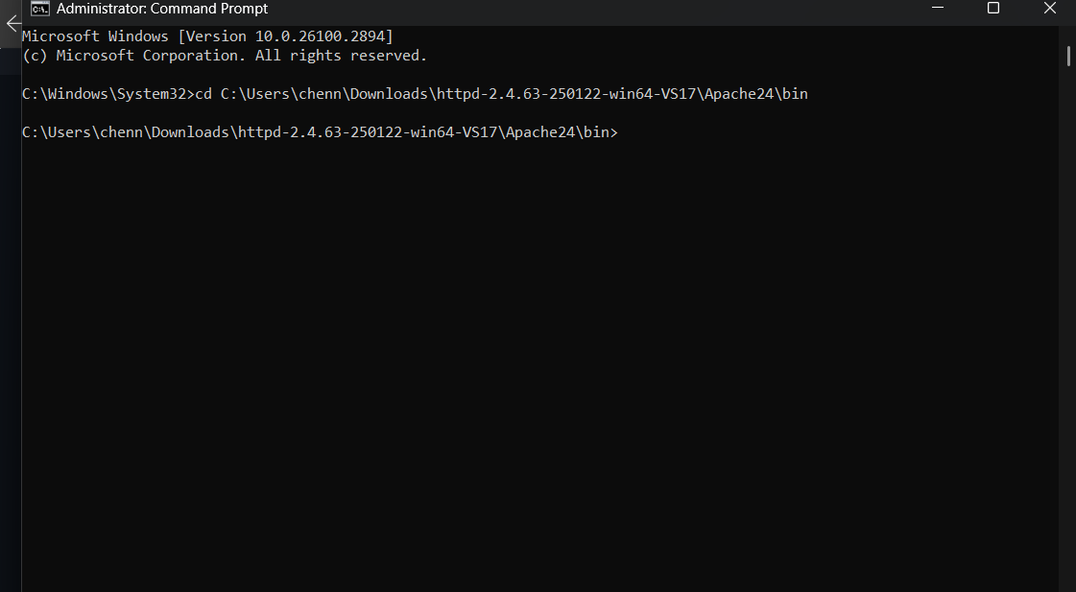

**Step 5 :**

Run the installation command : ***httpd.exe -k install***

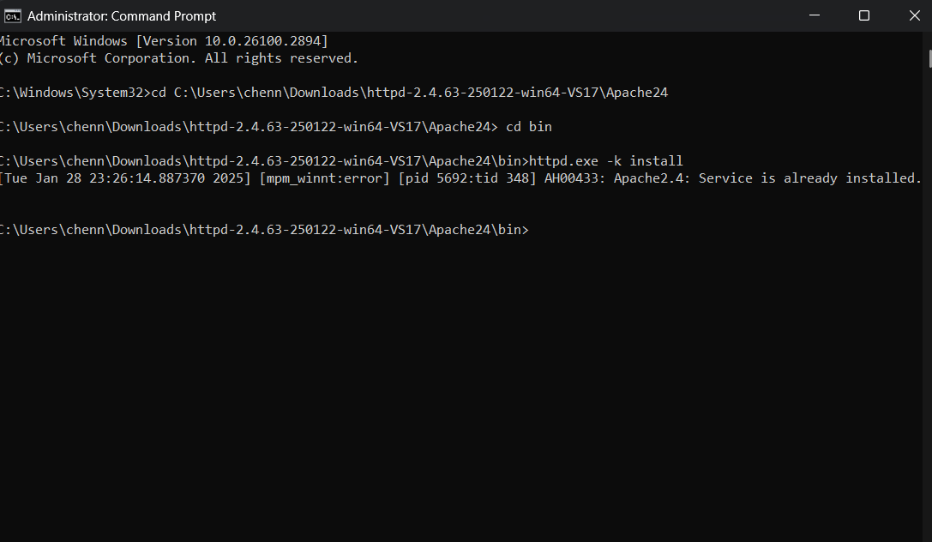

***Step 6 :***

Go to the Apache folder you downloaded, then go to the conf folder, and rightclick on the httpd.conf file; select 'Edit with Notepad'

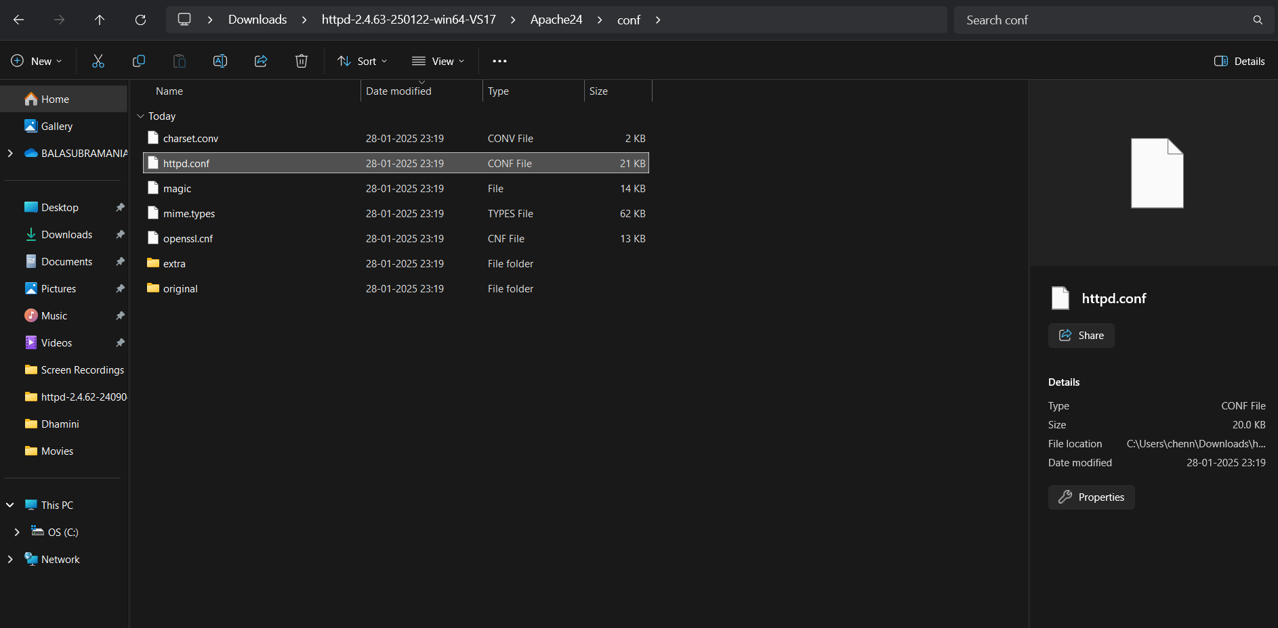

***Step 7 :***

Replace the content of the **httpd.conf file** with the provided configuration, ensuring the **SRVROOT** directive matches your Apache installation path. This setup configures the server's root directory, listening port, document root, logging paths, and permissions properly from the htdocs directory.

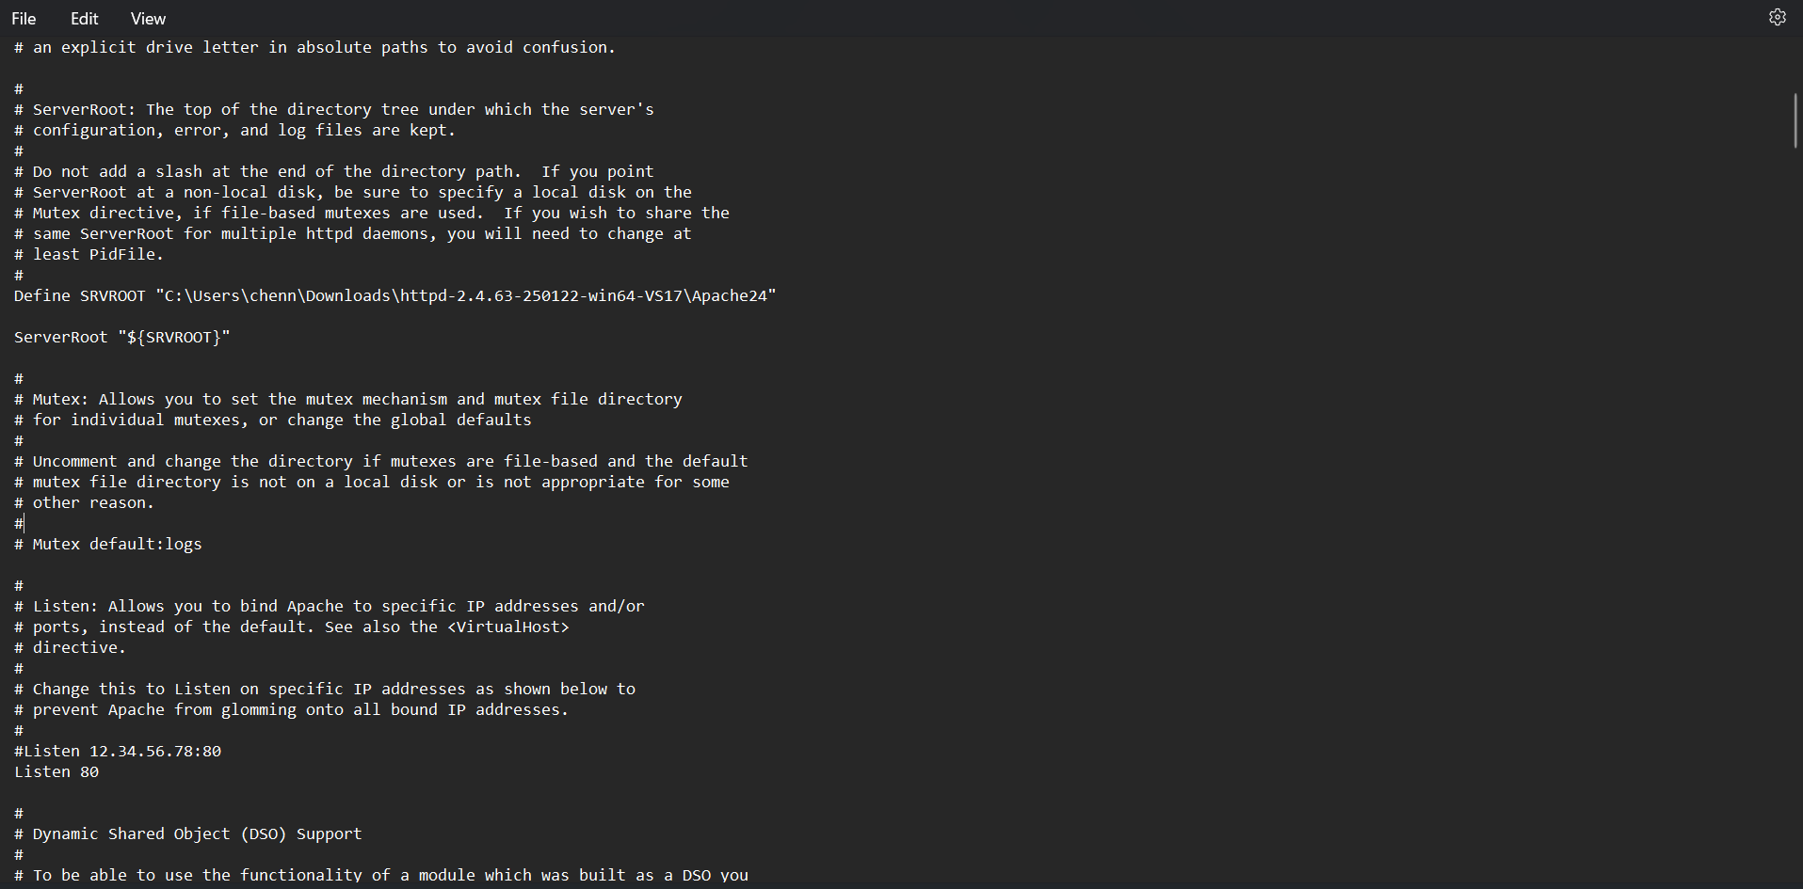

***Step 8 :***

Open Command Prompt and type the command httpd.exe -t to test the configuration file. If the configuration is correct, you should see 'Syntax OK'.

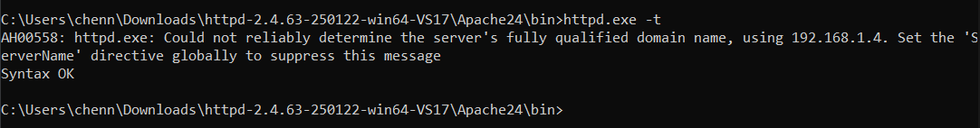

***Step 9 :***

Run the command httpd.exe -k.



***Step10:***

Go to the Apache folder, navigate to the htdocs folder, and find the index.html file. Right-click on it and select 'Edit with Notepad'.

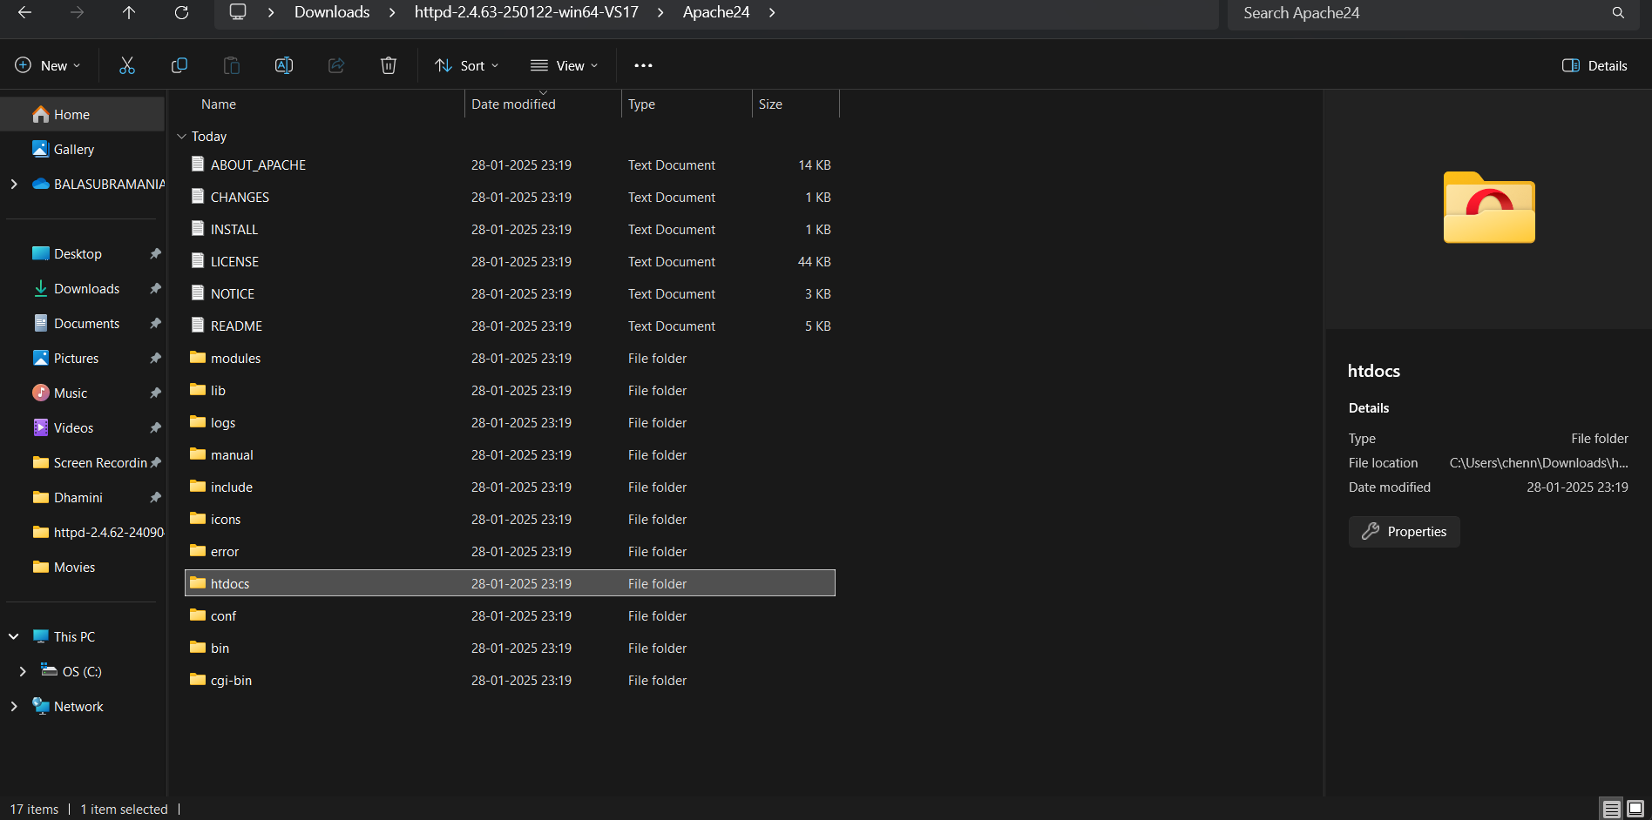

***Step 11 :***

Create a simple model to display your name in HTML.

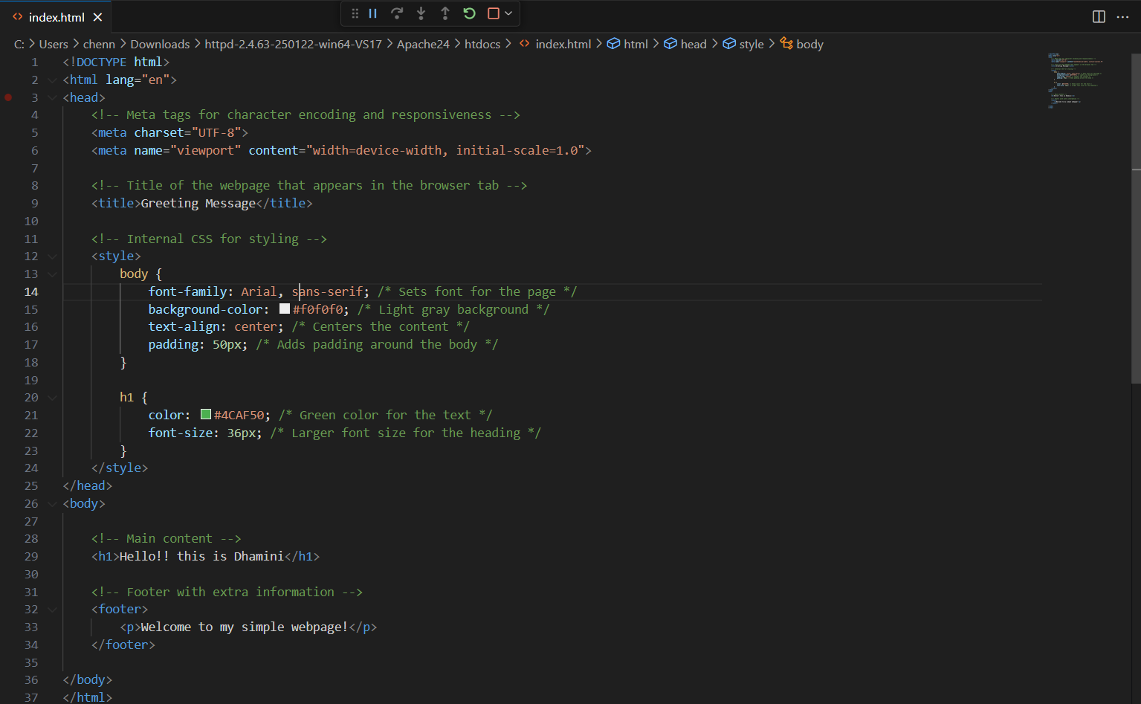

***Step 12 :***

Open the Chrome browser and type localhost/index.html in the address bar. You should be able to see the website hosted successfully.

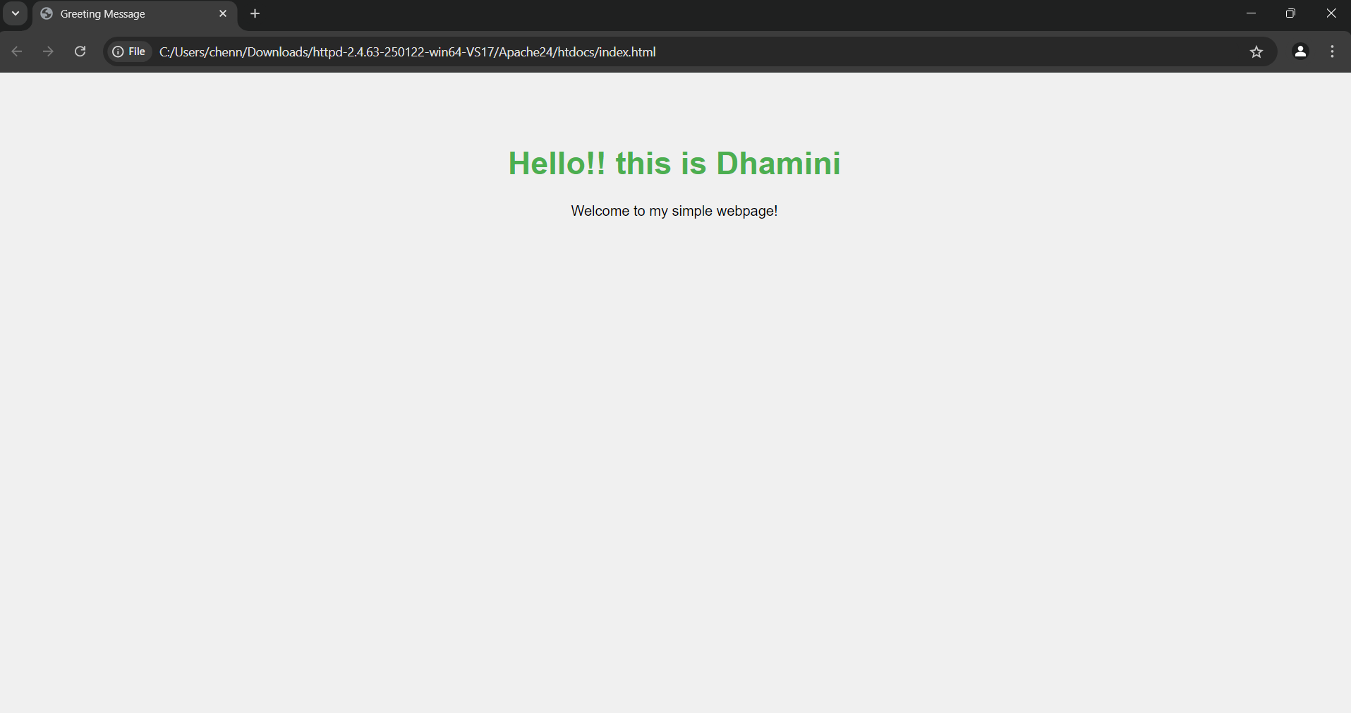

***Expected Outcome***

Completing this poc you will:

* Successfully install and operate an Apache server on your local computer.
* Publish a static HTML page locally that showcases your name.
* Learn the fundamentals of configuring a web server and hosting files.